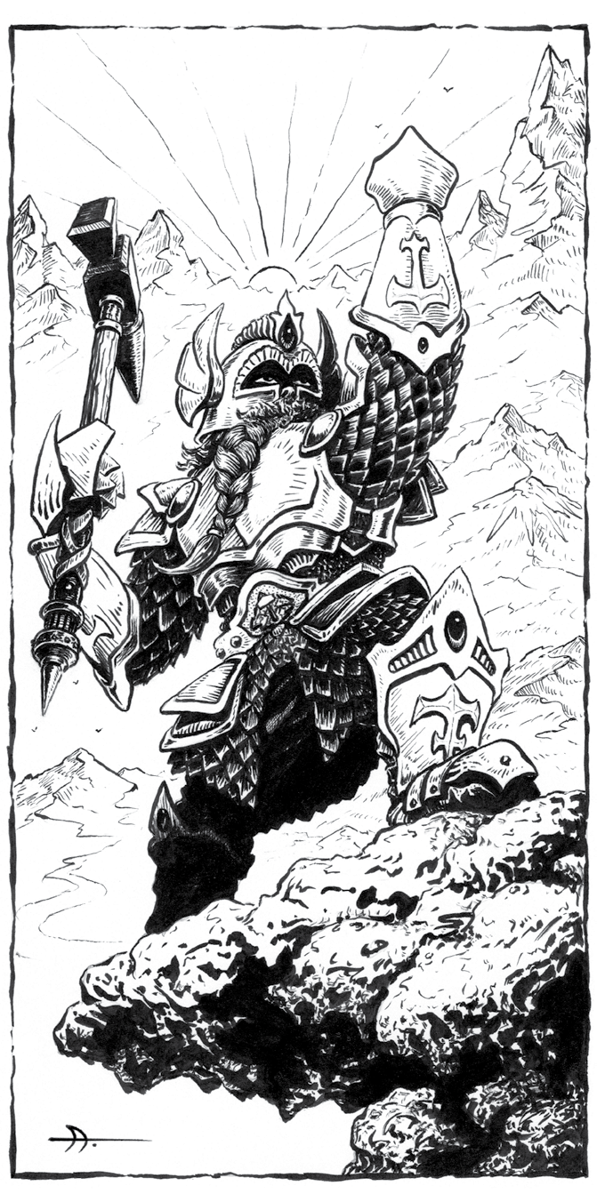
D aenthar

Der Bergfürst

Erde, Stein, Metall und Feuer,
Juwelen und unermüdliche Arbeit,
treuer Dienst und Ordnung
schaffen die Werke der Welt.

Streng und unerschütterlich ist Daenthar, der Herr der Heiligen Schmiede. Er ist der Gott der Erde und der Arbeit, der Handwerker, Prospektoren, Schürfer und Bergleute von Stein, Metall oder Edelsteinen. Man sagt, er habe die ersten Zwerge aus rohem Erdreich geformt, als die Welt noch jung war, und er führt und beschützt sie, während sie tief unter der Erde graben. Obwohl er mürrisch und ernst ist, wird der Bergfürst sowohl von jenen angerufen, die sich in die hohen Gebirgspässe wagen, als auch von jenen, die in die tiefsten Minen hinabsteigen. Daenthar wird all diejenigen beschützen, die ihm treu dienen.
Die Kleriker der Heiligen Schmiede tragen bei Zeremonien eine vollständige Rüstung. Wenn sie keine Opfer darbringen, keine Rituale für Daenthar durchführen oder nicht mit Feinden konfrontiert sind, tragen sie stattdessen heilige Gewänder, die vor allem an gut gearbeitete Arbeitskleidung erinnern. Der Gott verwendet einen aufrecht stehenden Schmiedehammer vor einem zerklüfteten Berg als sein heiliges Symbol.
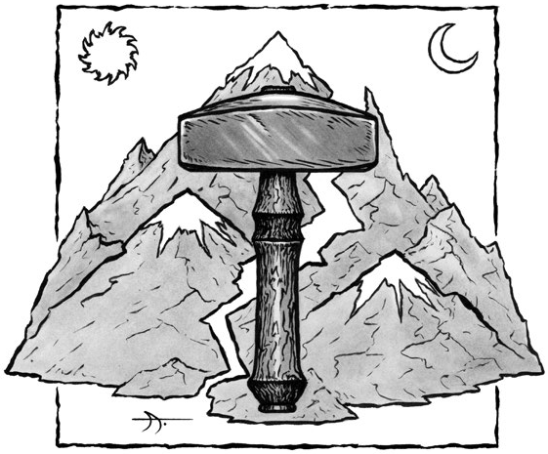
Die Lieblingswaffe des Bergfürsten ist der Hammer.
Daenthar
Stern and unwavering is Daenthar, the Lord of the Hallowed Forge. He is the god of the earth, or industry, of those who work in crafts, or who seek to draw the riches from the earth in terms of stone, metal, or gems. He is said to have crafted the first dwarves from raw earthstuff when the world was young, and to guide and guard them while they tunnel deep beneath the earth. Although dour and solemn, the Mountainlord is called upon by those who venture into the high mountain passes as well as those who delve into the deepest of mines. Daenthar is said to protect those who serve Him well.
Temples dedicated to Daenthar are rare, although the god himself is offered prayers and sacrifices widely. Where they are found, the Mountainlord’s clerics create heavily protected stone-walled holdfasts dedicated to their god. These act both as fortress and temple, and may extend deep beneath the ground. Travelers are happy to find such places, which offer respite from the dangers of the high passes.
The clergy of the Hallowed Forge wear full battle armor for ceremonies. When not offering sacrifices, conducting rituals to Daenthar, or faced with enemies, they dress instead in holy accoutrements resembling nothing so much as well-made workman’s clothing. The god uses an upright forging hammer, placed before a cracked mountain, as his holy symbol.
Daenthar is depicted as a stout human or a tall dwarf, often arrayed in full battle armor or standing over a forge or an anvil. Depictions of the Mountainlord are always carved in stone; any other depictions are considered blasphemous. Daenthar is among the most severe proponents of Law. He never breaks his sworn word, and demands that His clerics likewise
hold their vows. Thus, while the direct proponents of Daenthar are lawful, neutral – and even chaotic – beings will call upon the Mountainlord to bind an oath.
Sacrifices to Daenthar are made in service and wealth. Money and time are given to public service, and to glorify (or strengthen) the fortress-temples of the Mountainlord. A cleric in need may reduce his disapproval by promising
such works, but woe to he who breaks an oath to the Lord of the Hallowed Forge! Even promises made without a reasonable time frame to complete (as determined by the judge) act to increase, rather than decrease, disapproval.
There is never any doubt when Daenthar speaks to His faithful. The voice of the Lord of the Hallowed Forge may be heard in the crack of stone and the rumble of avalanches. He may cause a carven image of Himself to move and speak. His face may appear in the hot coals of the forge, or His voice in the ringing of hammer on iron. His identity is never in doubt, and the meaning of His words is always clear. Daenthar does not equivocate.
The Mountainlords’s favored weapon is the warhammer.
Lay on Hands
When a cleric of Daenthar attempts to heal a chaotic dwarf, the recipient is treated as being “adjacent” on the lay on hands chart (page 31 of the DCC RPG rulebook). A neutral dwarf is treated as “same”, while a lawful dwarf is healed with a +1d bonus on the dice chain to the spell check.
A cleric of Daenthar can use this ability to repair animated objects and similar constructs. This works in exactly the same way that healing for living creatures does, save that the will of the Mountainlord causes damage to the object to reverse.
Rust may be removed as if healing a disease, and broken mechanisms may be treated as broken bones. Because animated objects and constructs are never truly “alive”, they can be “healed” even centuries after being reduced to 0 hp.
Finally, by spending 10 minutes with appropriate tools, a cleric of Daenthar may attempt a lay on hands check to repair any mechanical device. This does not actually call upon divine power, and cannot alter or result in disapproval. If the check fails, the cleric may try again if he spends 1 hour on the next check. Another check may be allowed after 4 hours work, and a final check after 1d3 days work. This check is modified by the cleric’s Intelligence, rather than Personality.
The judge may require specific materials (or their equivalents) be available. For example, making a rusted portcullis move may require both a lubricant and a hard object to knock apart metal that has been rusted together. The judge may also rule that repairs are not complete and/or temporary (i.e., perhaps the rusted portcullis can be raised, but thereafter cannot be lowered again).
1-13 Failure.
14-19 A small, relatively simple device may be repaired.
20-22 A larger simple device, or a small device of medium complexity, may be repaired.
23-25 A large simple device, a medium-sized device of average complexity, or a small very complex device may be repaired.
26-28 A very large simple, a large device of average complexity, or a medium-sized very complex device may be repaired.
29-30 Any simple device, a very large device of average complexity, or a large very complex device, may be repaired.
31+ Any device may be repaired.
Turn Unholy
In addition to the normal creatures a lawful cleric can turn as unholy, clerics of Daenthar may attempt to turn animated objects and constructs, such as golems and beings made of clockwork. On a result of “K”, the cleric may instead choose to command the constructed beings for up to 1d3 turns. The cleric may not command more HD in constructs than twice his level in this manner. The constructs described in the Psalm of the Hallowed Forge are immune to this ability.
Titles
1 Aspirant to Stone
2 Fellow of the Forge
3 Journeyman of the Mountain
4 Craftsman of the Hallowed Forge
5 Master Craftsman of the Hallowed Forge
These level titles are not gender-dependent. A 3rd level female cleric is called a Journeyman of the Mountain, just as a male cleric is.
Disapproval
It is the role of clerics to be mortal embodiments of a higher power, extolling their deities’ virtues and shepherding the ignorant into the flock. In exchange for a life of devotion, deities grant great powers to their most favored disciples. Those who show disrespect by ineptly invoking holy power or acting in a manner contrary to their deity’s wishes run the risk of punishment. The table below contains a deity disapproval tailored for followers of Daenthar.
1 The cleric has lost his connection to the solid stone of the earth, and must spend 10 minutes meditating to restore this bond, as soon as possible (e.g., during combat, the cleric can wait until after the battle).
2 No mortal can encompass the profundity of Law enough to please Daenthar at all times. Now the cleric must pray and mediate for at least one hour to reestablish himself as an agent of the Law. If he fails to do this within 120 minutes, he takes a -1 penalty to all spell checks until the hour’s mediation and prayer is complete.
3 The cleric must donate 100 gp or 8 hours of labor to community service – building or repairing walls, designing irrigation systems or aqueducts, performing smithwork or stonework, etc. If these conditions are not met within 24 hours, the cleric takes a -1 penalty to all spell checks until they are.
4 The cleric immediately incurs an additional -1 penalty to all spell checks that lasts until the next day.
5 Daenthar demands that the cleric undertake the twin tests of humility and righteousness. For the next 24 hours, the cleric must obey the orders of others, if they do not further the aims of Chaos, but must eschew those orders which would work against Law. Each time he fails to obey an order he should, or obeys an order he should not, he takes a cumulative -2 penalty to all spell checks.
6 The cleric immediately incurs a -1 penalty to lay on hands attempts. This penalty remains in place until the cleric completes a quest to heal the sick or crippled. The quest must be of the cleric’s own devising, and any profit he gains from the quest must be donated to public works.
7 The cleric must endure a test of faith. For the next 24 hours, he cannot use his lay on hands ability to heal himself, although he can still heal others. If the cleric endures this test without complaint (judge’s determination), his ability to heal himself is thereafter restored. If not, his disapproval increases by 1 for the next 24 hours.
8 The cleric immediately incurs a -4 penalty to spell checks on the specific spell that resulted in disapproval (including laying on hands and turning unholy, if those were the acts that produced disapproval). This lasts until the next day.
9 Daenthar wishes the cleric to rely less upon his spells and more upon himself. The cleric immediately incurs a -2 penalty to all spell checks that lasts until the next day.
10 No magic is used without consequence. The caster immediately loses the power to cast one random spell until the following day, lest the energy released aid the forces of Chaos.
11 The cleric has lost spiritual position with regards to community, immediately incurring a -2 penalty to all spell checks. This remains until the spiritual link is restored. For every full day spent performing public works for which the cleric gains no compensation, he may attempt a DC 15 Willpower save. Success means that he has regained his connection to the community, and the penalty is removed.
12 Daenthar turns His face from the cleric. Until Daenthar is mollified, the cleric cannot gain XP or levels as a cleric. This requires a public donation of no less than 100 gp per level the cleric has acquired. Once such a donation is made, the cleric can again gain XP and levels, but does not accrue “back pay” (so to speak) for XP missed while he was disowned.
13 The cleric loses access to two randomly determined level 1 spells, which cannot be cast until the next day.
14 The faithful of Daenthar rely upon skill of hands and strength of limb, even more than reliance upon divine power. This is a lesson the cleric must learn. For each spell cast, he takes 1 point of temporary damage to Strength, Agility, or Stamina per spell level (e.g., a level 3 spell causes 3 points of temporary ability damage). The cleric may decide which ability score to apply each point of this damage to, but may not use magic to heal it.
15 Daenthar is not forgiving this day. When the cleric rests for the night, he does not “reset” his disapproval range at the next morning – it carries over
from this day to the next. The disapproval range resets as normal the following day.
16 For some broken vow in thought or deed, Daenthar removes the cleric’s ability to lay on hands for 1d4 days. Only after this time does the cleric regain his healing abilities.
17 The cleric loses access to 1d4+1 spells, randomly determined from those he knows. He cannot cast those spells for the next 24 hours.
18 The cleric learns what it means to be caught between the hammer and the anvil! Every time the cleric calls upon Daenthar to turn unholy, lay on hands, or cast a spell, the cleric takes 1d5+3 points of damage under the gentle ministrations of the Lord of the Hallowed Forge, which cannot be magically healed. This condition lasts for 24 hours.
19 For the next 24 hours, the cleric may only attempt to lay on hands on any given creature once.
20+ Only the extremely arrogant or foolish would push the unyielding Mountainlord so far! The cleric immediately loses all access to spells, the ability to turn unholy, and the ability to lay on hands. As an act of penance, each day (including the first), the cleric may give away his worldly possessions. The percentage of worldly possessions given away (based on the cleric’s possessions at the time the disapproval occurred) is the percent chance that Daenthar relents and restores the cleric’s divinely granted abilities on the following day. For example, a cleric who donates half his worldly goods has a 50% chance of being restores to Daenthar’s good graces on the next day. If Daenthar does not relent, and the cleric then donates half of what remains, he has a 75% chance of being restored on the following day. If no additional sacrifice is made, there is no chance of Daenthar relenting on a subsequent day.
Canticles Of Daenthar
Music and ritual play central roles in many worship services. Raised in prayer, the voices of the faithful can invoke minor powers of their deity, much like a spell. The following powers may be learned by clerics of Daenthar:
Level 1: Chaunt of the Unmoving Mountain
Level 3: Song of Stone
Level 5: Psalm of the Hallowed Forge

Chaunt Of The Unmoving Mountain
All clerics of Daenthar are able to sing the Chaunt of the Unmoving Mountain, granting them great stability when his feet are in contact with earth or stone. Direct contact is not necessary; a cleric wearing boots or foot armor is equally able to utilize the Chaunt. Starting on the second round, while chanting prayers to the Mountainlord, the cleric gains the following benefits. However, the cleric cannot otherwise speak or cast spells, and every instance of using the Chaunt of the Unmoving Mountain (or for each 10 minutes of continual use) causes the cleric’s disapproval to automatically increase by 1.
• The cleric adds his level to Strength checks and Reflex saves to avoid falling, tripping, or being moved against his will.
• The cleric subtracts his level from Mighty Deeds, such as trips, throws, or pushbacks, intended to move him.
• If the cleric is moved (for example, due to a giant’s critical hit), he subtracts his level in feet from how far he is moved. If the result is 0 or less, the cleric is not moved.
Song Of Stone
This low, droning song allows a cleric of Daenthar to harden his flesh to a stone-like consistency. The cleric must anoint himself with holy mineral oils (costing 15 gp) while singing, a process which takes a full turn to complete. The cleric then makes a spell check and consults the table below. It should be noted that any AC bonus received does not stack with armor; the cleric gains only the better of the two bonuses.
1-15 Failure.
16-17 Cleric gains +2 bonus to AC for the next hour.
18-23 Cleric gains +2 bonus to AC for the next hour, and any damage the cleric takes is reduced by 1 point.
24-25 Cleric gains +4 bonus to AC for the next 2d6 hours, and any damage the cleric takes is reduced by 2 points.
26+ Cleric gains a +6 bonus to AC until the next dawn. Any damage the cleric takes is reduced by 5 points.
Dwarves And The Mountainlord
Normally, only humans can become clerics, but Daenthar is the creator-god of the dwarves and allows them among his faithful. The judge may rule that dwarven priests of Daenthar are NPCs only, using the stat blocks below. If the judge desires, lawful dwarves may choose to become clerics of Daenthar upon reaching 1 st level. In this case, the dwarf retains the racial characteristics possessed as a 0-level character, but gains no further Dwarf class abilities.
Dwarven acolyte: Init +0; Atk warhammer +1 melee (1d8) or harmful spell (see below); AC 10; HD 1d8; MV 20’; Act 1d20; SP harmful spell 2/day; SV Fort +1, Ref +0, Will +2; AL L.
Dwarven priest: Init +0; Atk warhammer +3 melee (1d8) or harmful spell (see below); AC 15; HD 1d8; MV 20’; Act 1d20; SP harmful spell 3/day; SV Fort +3, Ref +0, Will +4; AL L.
The harmful spells of dwarven followers of Daenthar take several forms:
1d5 Spell
1 The Fist of Daenthar: Stone fist flies from the caster up to 30’, striking with a +3 attack bonus for 1d4+2 damage.
2 Heat of the Forge: Target within 60’ takes 1d3 damage on the first round, 1d4 damage on the second round, 1d5 damage on the third round, and so on up the dice chain until a DC 12 Fort save succeeds. Characters in metal armor suffer +1 damage per round.
3 Hammer of the Mountain: The caster can hurl his warhammer up to 50’, with a +5 bonus to hit, and doing 1d8+4 if successful (DC 15 Ref save for half). The warhammer is consumed by the spell, potentially leaving the caster weaponless.
4 Weight of Stone: Target within 100’ feels its weight increased by 150%, slowing the target’s movement by -10’ per round and reducing its initiative by -1d3. The effect lasts 1d5+2 rounds. DC 10 Will save negates.
5 Visage of Stone: Target within 30’ is transformed into stone, unless a DC 10 Fort save is made. The effect lasts only 1d3 rounds.
Psalm Of The Hallowed Forge
This psalm allows a favored cleric of Daenthar to request the aid of the Mountainlord in the form of one or more constructed servants created by the Lord of the Hallowed Forge. All of these creatures appear to be made of burnished black metal, which burns elves for 1 point of damage per round of contact (or +1 damage per successful attack). All of these creatures are extreme representations of Law. They are obedient to the cleric so long as they are not asked to oppose Law or bolster Chaos, and they may turn on a cleric who wishes to use them for sinful purposes.
Minor constructs are human-sized. Major constructs are 8’tall. When a construct is reduced to 0 hp, or the time it has been sent for expires, it simply fades away.
1 Failure and worse! A minor construct is sent to chastise the cleric, attacking for 2d6 rounds before fading away. The wounds caused by the construct cannot be magically healed, but the cleric need not succeed in a Luck check to be recovered if reduced to 0 hp.
Minor construct: Init +0; Atk warhammer +3 melee (1d8+2); AC 15; HD 2d12; MV 20’; Act 1d20; SP immune to mind-affecting, half damage from heat or cold, all damage taken reduced by 2 points; SV Fort +5, Ref +0, Will +7; AL L.
2-19 Failure.
20-21 A minor construct is sent to aid the cleric for 1 turn. Minor construct: Init +0; Atk warhammer +3 melee (1d8+2); AC 15; HD 2d12; MV 20’; Act 1d20; SP immune to mind-affecting, half damage from heat or cold, all damage taken reduced by 2 points; SV Fort +5, Ref +0, Will +7; AL L.
22-27 2d5 minor constructs are sent to aid the cleric for 1 hour. Minor construct: Init +0; Atk warhammer +3 melee (1d8+2); AC 15; HD 2d12; MV 20’; Act 1d20; SP immune to mind-affecting, half damage from heat or cold, all damage taken reduced by 2 points; SV Fort +5, Ref +0, Will +7; AL L.
28-29 A major construct is sent to aid the cleric for 1d3 hours. Major construct: Init +0; Atk warhammer +5 melee (1d8+3); AC 20; HD 4d12; MV 30’; Act 2d20; SP immune to mind-affecting, half damage from heat or cold, all damage taken reduced by 5 points; SV Fort +10, Ref +0, Will +12; AL L.
30+ 1d3 major constructs are sent to aid the cleric until the next dawn. Major construct: Init +0; Atk warhammer +5 melee (1d8+3); AC 20; HD 4d12; MV 30’; Act 2d20; SP immune to mind-affecting, half damage from heat or cold, all damage taken reduced by 5 points; SV Fort +10, Ref +0, Will +12; AL L.

